PRACTICAL- 3

OBJECTIVE- CREATE AN S3 BUCKET IN AWS
Steps to Create an S3 Bucket in AWS
- Log in to AWS Console: Go to AWS Console, sign in with your AWS account credentials.
- Navigate to S3
- In the search bar at the top, type S3.
- Click on S3 (Scalable Storage in the Cloud).
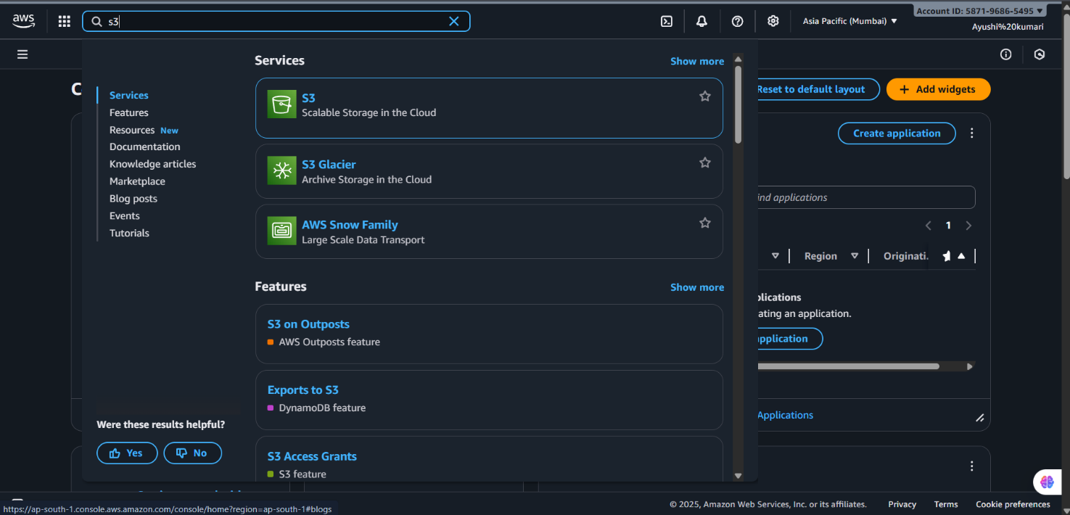

- Create a New Bucket
- Click on “Create bucket” button.
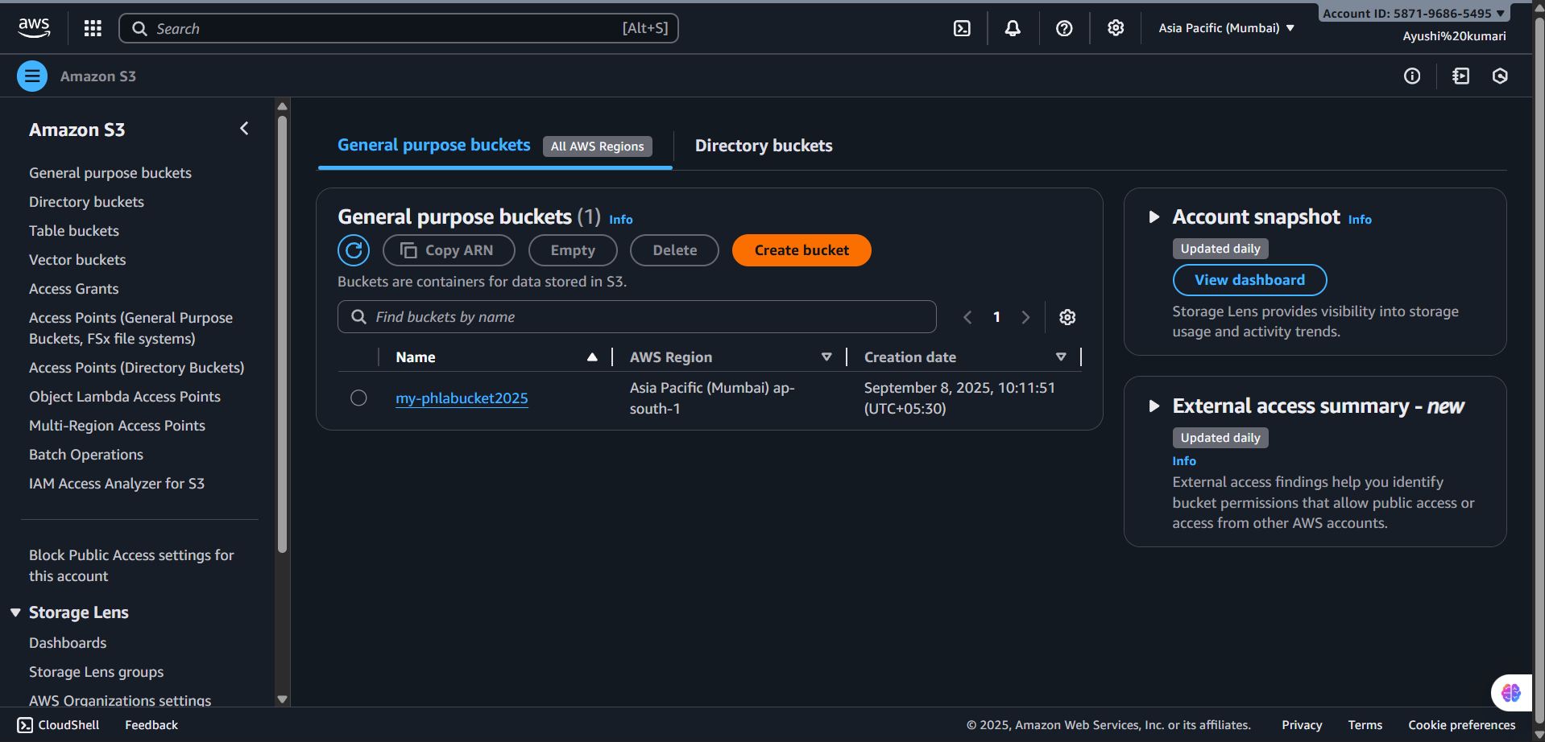
- Configure Bucket Settings
- Bucket name: Enter a unique name (e.g., my-first-s3-bucket-2025).
- Bucket names must be globally unique across AWS.
  - AWS Region: Select a region (choose one closest to your users for better performance).

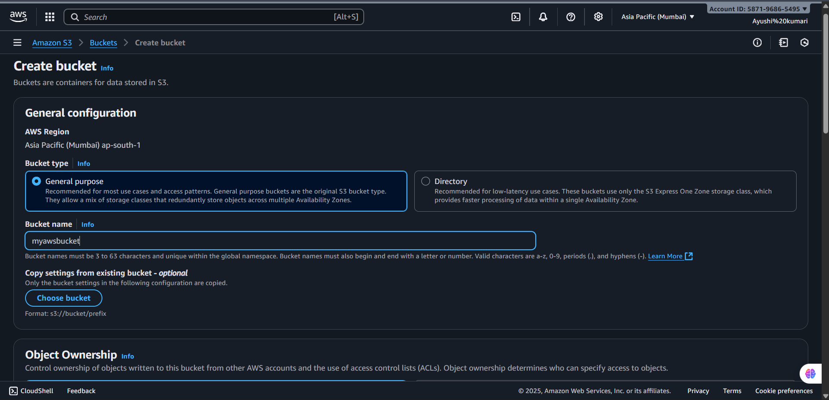
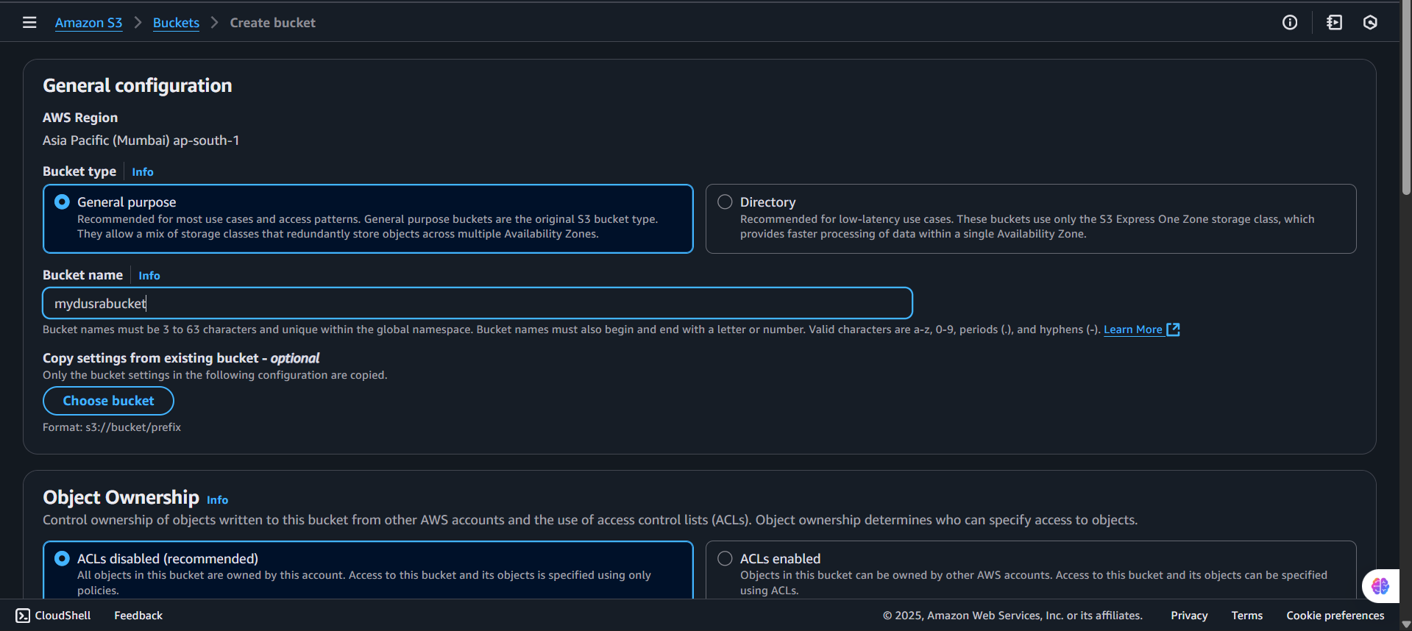

- Set Bucket Options
- Object Ownership:
- Choose ACLs disabled (recommended) for most use cases.
- Block Public Access:
- By default, all public access is blocked (recommended for private buckets).
- If you need a public bucket (for hosting static websites), uncheck the option and acknowledge the warning.
- Configure Bucket Settings (Optional)
- Versioning: Enable if you want to keep multiple versions of an object.
- Encryption: Enable default encryption if required.
- Tags: Add key-value tags if you want to manage cost tracking or organization.
- Review your settings.
- Click Create bucket.

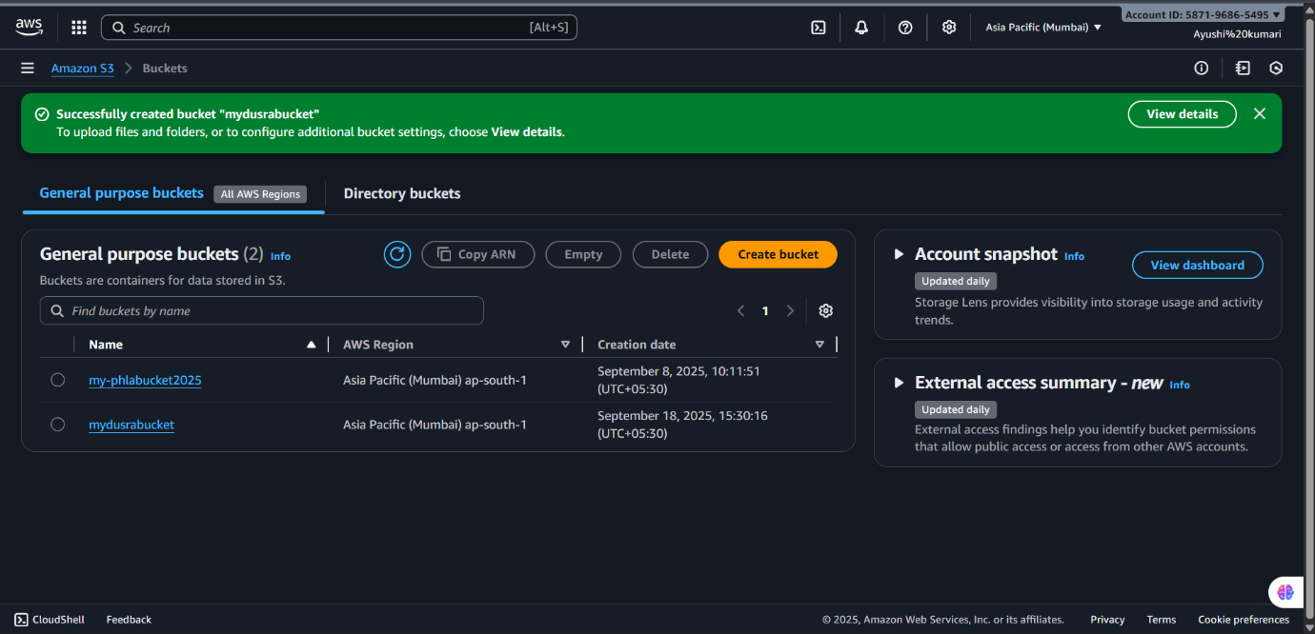

- Upload Objects (Optional)
- After creation, open the bucket.
- Click Upload → Add files.
- Select your file(s), then click Upload.

